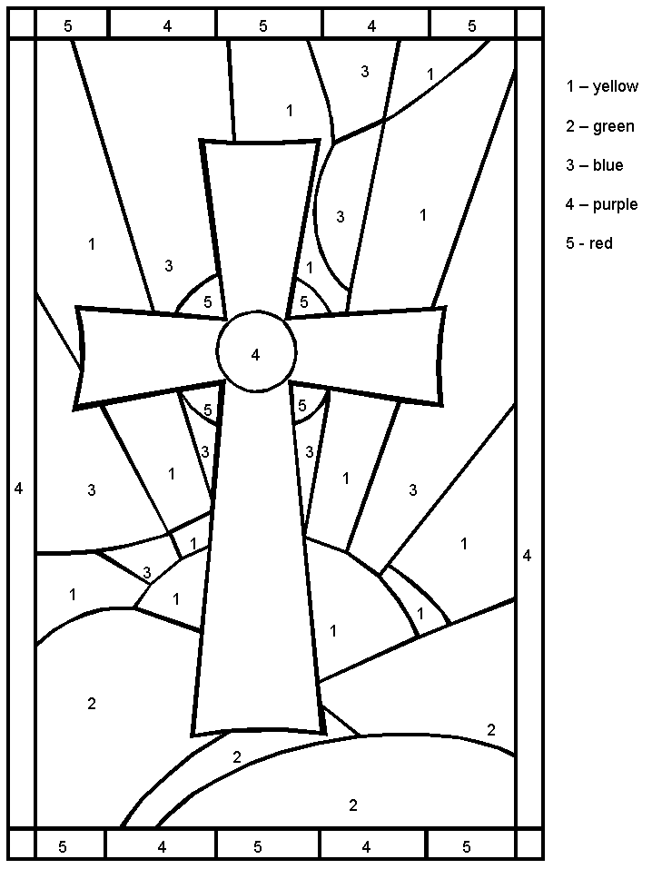
Easter Spelling List! (5)
4/15 – 4/18

1. palm branches
2. betrayal
3. risen
4. Pontius Pilate
5. Everlasting
6. temple curtain
7. earthquake
8. tomb
9. centurion
10. resurrection
11. Easter
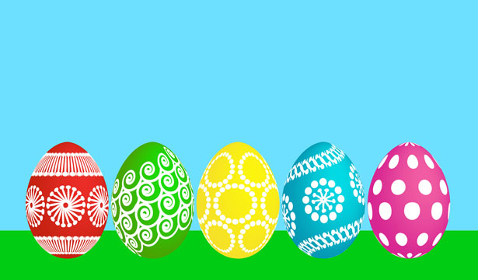
12. revival
13. Ephesians 2:8
14. crown of thorns
15. atonement
** “Eli, Eli, lema sabachthani!” (My God, My God, why have You forsaken me?)

