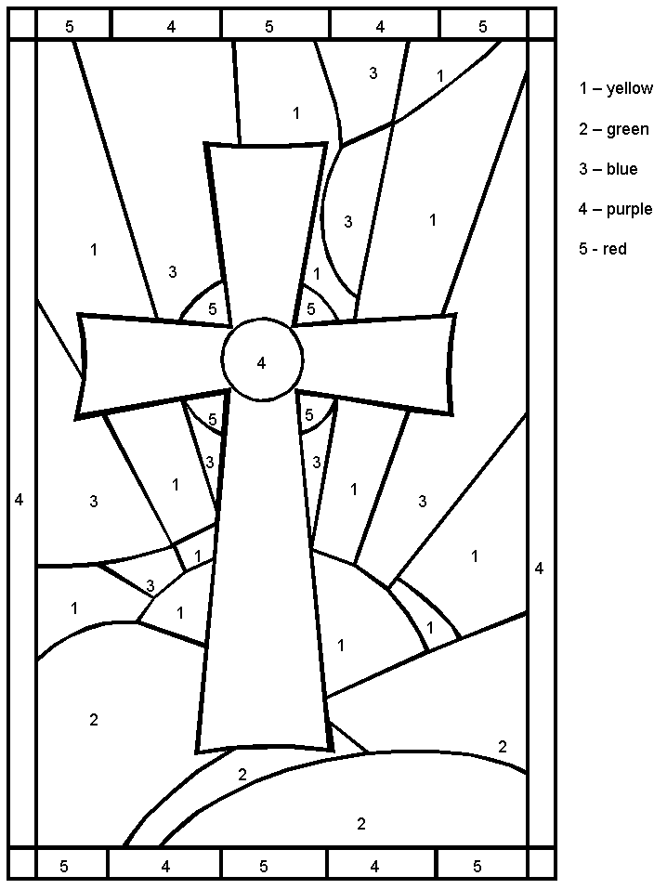
Easter Spelling List! (4)
4/15 – 4/18

1. Peter Cottontail
2. Easter break
3. delicious candy
4. the holy cross
5. crucifixion
6. resurrection
7. Easter Sunday
8. disciples
9. Passover
10. Good Friday
11. olive tree
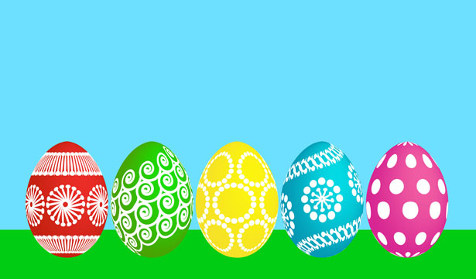
12. betrayal

