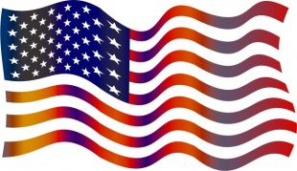
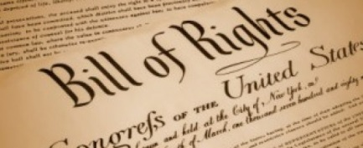
Democracy Spelling List!
1. U.S. Constitution
Homework
Monday: ABC Order
Tuesday: Definitions #1-11
Wednesday: 3x Each (cursive)
Thursday: Study with a parent!
Friday: Spelling + Vocab. Test

2. Bill of Rights
3. amendments
4. democracy
5. executive branch
6. legislative branch
7. judicial branch
8. Congress
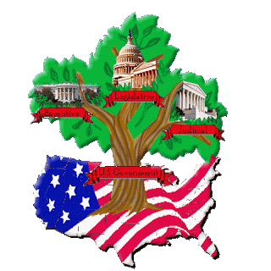
9. House of Representatives
10. Senate
11. ratify

