C:\Users\lhill\AppData\Local\Microsoft\Windows\Temporary Internet Files\Content.IE5\LCLTSOPQ\MC900295730[1].wmf

**Colonial Occupation Project Rubric**

**I. **Research Paper:**

**Title Page: _________ pts.**

**Introductory Paragraph: _________ pts.**

**Body:**

Name of / Explanation of Occupation: ________ pts.

Location of Work: ________ pts.

(ie. New England town, Southern plantation,

workshop, home, boat, etc.)

C:\Users\lhill\AppData\Local\Microsoft\Windows\Temporary Internet Files\Content.IE5\AUF609HK\MC900239443[1].wmfGoods / Services Provided: _________ pts.

Tools / Supplies Used: ________ pts.

**Concluding Paragraph: _________ pts.**

**Editing / Neatness: _________ pts.**

**Bibliography Page: _________ pts.**

**II. Projects**

**\*\*Portrait of Tradesperson at Work:**

Full-Page Drawing: _________ pts.

Neatness: _________ pts.

**\*\*Diorama: _________ pts.**

**\*\*Presentation: _________ pts.**

C:\Users\lhill\AppData\Local\Microsoft\Windows\Temporary Internet Files\Content.IE5\LCLTSOPQ\MC900231134[1].wmfC:\Users\lhill\AppData\Local\Microsoft\Windows\Temporary Internet Files\Content.IE5\YBSPUMSB\MC900051020[1].wmf

**Total: ___________ pts.**

Colonial Occupation Project – Guidelines

Due :_______________

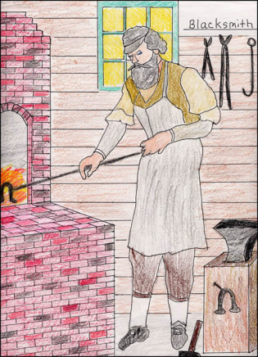

I. Draw a portrait of your tradesperson at work.

Your portrait must:

1. Be neatly drawn in portrait layout (not landscape).
2. Be neatly (and completely) colored using colored pencils.
3. Have the person very large (more than half as tall as the picture).
4. Show the clothing the person would have worn for the job.
5. Show what the artisan (trades person) is doing.
6. Include several tools and materials used by the tradesperson.

II. Create a diorama showing a sneak peek into your tradesperson’s worksite. Make sure all “walls, floor, and ceiling” are drawn to resemble his/her actual workplace. (You may print pictures to help you decorate your walls too.) Include 3-D objects to help create your tradesperson’s workplace!

You may want to refer to the following website for instructions on making a diorama: <http://www.squidoo.com/shoebox-diorama>

III. Prepare a short talk, about one minute, explaining the trade being represented. Practice the talk so classmates can tell rather than read about your trade.